Separating Associations from Semantics: Differences in Priming and Judgments

Erin Buchanan

Missouri State University

Erin Buchanan

Missouri State University

Department of Psychology

901 S National Ave

Springfield, MO 65804

Phone: 417-836-5592

Email: erinbuchanan@missouristate.edu

Acknowledgements

The author would like to thank William S. Maki for his many comments, helpful thoughts, and encouragement throughout the duration of this project.

Abstract

Several experiments were performed to show the differences in associative and semantic memory through a hybrid judgment and rapid serial visual presentation (RSVP) task, which was created from the work of Maki (2007a; Maki, Frigen, & Paulsen, 1997) and Davenport and Potter (2005). Participants judged related word pairs, which primed a target word in an RSVP task. This task was used to show the early and persistent processing of associative information over semantic information. In three experiments, associative information was primed separate of semantic information and predicted both associative and semantic judgments. These results are used to discuss the nature of associative memory processing and support an information hierarchy in memory storage.

Separating Associations from Semantics: Differences in Priming and Judgments

Semantic memory is the memory store that contains all the dictionary knowledge or facts we have gathered on the meaning of words (Tulving, 1993). The interconnections between those meanings are studied through the use of semantic priming. Semantic priming occurs when there is a facilitation of processing (i.e. faster reaction times for reading) of one word following the presentation of a word related in meaning (Meyer & Schvaneveldt, 1971). So, if people are reading about MONEY or LOANS, the word BANK is much easier to process because MONEY’s related meanings have already been activated in semantic memory. A model used to understand semantic priming, in much the same way as Collins and Loftus (1975) originally outlined, is the Interactive Activation Model (Stolz & Besner, 1996). The Interactive Activation Model (IA) was first proposed to understand how word context would change letter perception (McClelland & Rumelhart, 1981). Stolz and Besner (1996; 1999) have expanded this model to explain semantic priming using semantic store where words are connected to their meanings.

One issue with semantic priming has been the use of self-selected stimuli for experimental research. Semantic relationships are not the only type of relationship between pairs of words. Associative relationships are said to be the relationships of words that occur together frequently in text and speech, such as HELP and WANTED (Nelson, McEvoy, & Schreiber, 2004). Fischler (1977) was one of the first experimenters to try to separate associative connections to get “pure” semantic priming using a lexical decision task. Many others have followed suit showing only semantic priming (McRae & Boisvert, 1998), only associative priming (Thompson-Schill, Kurtz, & Gabrieli, 1998) or a combination of both types of priming (Hodgson, 1991; Williams, 1996; Ferrand & New, 2004) using traditional priming techniques such as naming and lexical decision. These studies selected word pairs that appeared to have one relation or the other, and then experimenters normed the words by having participants rate the word pairs. Word pairs were then generally passed down experiment-to-experiment, which perpetuated the use of words that were not controlled. The problem was and is that most studies of pure semantic priming have weak to moderate associative relationships (Lucas, 2000; Hutchison, 2003).

With the advent of large databases of associative (Nelson et al., 2004) and semantic (Maki, McKinley, & Thompson, 2004) norms, controlling for opposing relationships has become much easier. The Nelson et al. (2004) free association norms contain over 72,000 associative word pair combinations. Forward strength (FSG) is the probability that a cue word will elicit a response word, while backward strength (BSG) is the probability that the response word will elicit the cue word. Cueing with the word CAT will bring to mind the response MOUSE about 26% of the time (FSG for CAT-MOUSE), while MOUSE will elicit CAT about 54% of the time (BSG for CAT-MOUSE). Free association measures memory due to experience, so common phrases and culture are embedded in the norms (such as the word pair ROCK-ROLL).

WordNet is a large-scale electronic dictionary that links words through a hierarchical network, where nodes are linked by relationship (such as is-a or has-a). This dictionary has been used to create a measure of semantic similarity, JCN, which is named after Jiang and Conrath (1997) who created the measurement (Maki et al., 2004). JCN measures semantic distance by combining information on how far along the hierarchy a word appears (i.e. how specific it is) and how far (how many links) it is from the word it is paired with. Both of these databases provide an easy and efficient way of dissociating associative and semantic priming by directly creating word pairs without the opposing relationship.

The experiments presented here are designed to dissociate semantic and associative priming by making use of these databases. Word pairs were created with orthogonal relationships, so that priming was exclusively due to one relationship or another. Studying the separation of associative and semantic priming will help illuminate how associations fit into current models of priming, specifically the IA model. Associative links have been speculated to be stored between words at the lexical level (Williams, 1996), which would indicate that priming for associations could be present without semantics. Furthermore, associative links stored at the lexical level would imply that associative information cannot be restricted or blocked as with previous findings of semantic blocking (Smith & Besner, 2001).

Additional support for differences in associative and semantic information use can be seen with word pair judgment tasks. In an associative judgment task, participants are asked to judge word pairs by asking how many people out of a 100 would name a response word given a cue word (i.e. 76 people would say FOUND in response to LOST). In a semantic judgment task, participants are asked to judge word pairs on their feature overlap (i.e. how many features do these items share). Their ratings are then compared to associative and semantic database scores. Associative information (FSG) predicts both associative judgments (Maki, 2007a; 2007b) and semantic judgments (Buchanan, Maki, & Patton, 2007), while semantic database scores only predict semantic judgments (Maki, Krimsky, & Munoz, 2006).

Apparently, selectively attending to associative information during memory judgments blocks use of semantic information (but not vice versa). But we do not know whether the locus of this blocking of semantic information is early or late during the cognitive processes engaged by the judgment task. The blocking effect could arise early in processing if selective attention to associative information prevents activation of semantic features. The effect could occur later in processing if semantic information is activated and available but ignored when judging associative strength. The experimental task then is to determine whether semantic information survives associative processing. If it does, then we would conclude that the locus of the blocking effect is relatively late in the sequence of processes leading to an associative judgment.

In this experiment, a variation of the priming task appropriate for assessing the persistence of semantic information beyond the act of making a memory judgment was created. The rapid serial visual presentation (RSVP) technique that has been shown to be sensitive to semantic and associative relations among words was used (e.g., Davenport & Potter, 2005; Maki et al., 1997). In the hybrid task, each trial began with a judgment made on a pair of words that were presented simultaneously; then followed a stream of rapidly presented distractors that contained one target word and the subject was asked to recall the target. In some of these trials, the target was associatively or semantically related to one of the judgment words. In other trials, the target word was not related to either of the judgment words.

Based on the previous RSVP research, increased accuracy was expected in recalling the target word when the priming word in the judgment pair was related to the target. If associative judgments only activate associative information, then semantic priming should be reduced or prevented. However, both semantic and associative information appear to be activated during a semantic judgment task. Therefore, during the semantic judgment trials, both semantic and associative priming should be seen.

Experiment 1

Method

*Participants*

All 36 participants were recruited from the human subjects’ pool, and all participants received general psychology course credit for their participation. Two participants were excluded from this analysis: these two participants performed below 20% correct on the RSVP task, usually by typing one of the judgment words instead of the RSVP stream word.

*Design*

The structure of the hybrid trial is illustrated in Figure 1. Each trial in the experiment consisted of two parts. The trial began with a pair of words to be judged semantically or associatively. The second part consisted of an RSVP list of distractors that contained one target word; the target word was associatively related, semantically related, or completely unrelated to one of the words in the judgment pair (the priming word). The target word appeared at one of three serial positions in the RSVP list (1, 3, or 6). Thus the complete 2 x 3 x 3 within-subjects design included as factors: Judgment Type, Prime-target Relation, and Lag.

*Materials*

A total of 216 triplets of words were selected using associative (Nelson et al., 2004) and semantic (Maki et al., 2004) databases. Each triplet contained two words used in the judgment phase of each trial. The third word was the target word that appeared in the RSVP stream. One of the judgment words, the prime, was strongly related associatively or semantically to the target word; the other judgment word was not related in any way to the target. The two words in the judgment pairs were modestly related, both associatively and semantically, to each other. For example, in Figure 1 HORSE-COW-PONY is the word triplet presented. HORSE-COW is the judgment pair that would be associatively or semantically judged. HORSE-PONY is an example of a semantically related prime-target pair because the words share features, such as TAILS, CAN RIDE, GALLOPS, etc. COW-PONY are unrelated in the semantic and associative database.

The means and ranges for database variables are listed in Table 1. For associative word pairs, the forward association was kept as high as possible, while insuring no backward relationships and keeping the semantic similarity measure very low. The same procedure was used to create semantic word pairs; semantic similarity was kept high, while association was kept low. For example, DEVELOP and CREATE are semantically related but only weakly associatively related; PEANUT and BUTTER are strongly associatively related but weakly semantically related. The 54 associative prime-target pairs were strongly related in the forwards direction, and these associative pairs were only weakly related semantically. The 54 semantic prime-target pairs were strongly related semantically but weakly related associatively.

The words in each of the remaining 108 prime-target pairs were not related to each other. These unrelated pairs were created by randomly re-pairing words in the databases so that these pairs were neither associatively nor semantically related. For example, SAYING and SCALE are neither associatively nor semantically related. The unrelated pairs were used as a baseline to evaluate priming and also to control for relatedness proportion. This ratio was kept at 0.25 for each of the different pair types or 0.5 for the whole experiment.

Judgment pairs were created by combining each prime word with another word that was both semantically and associatively related to the prime word.  Regardless of the prime-target relation, the words in the judgment pairs were always related, both associatively in the forwards direction and semantically. Both relationships were allowed because both semantic and associative judgments were made on the same pairs (by different participants). For example, in the triplet ROAR-LION-SCREAM, the judgment pair was ROAR and SCREAM and the prime target pair was ROAR-LION; LION and SCREAM were unrelated.

The 216 triplets were randomly divided into two sets. Each set contained 27 associative prime-target pairs, 27 semantic prime-target pairs, and 54 unrelated pairs. Each participant experienced both sets of word triplets. One set was assigned to the associative judgment condition and the other set was assigned to the semantic judgment condition. These assignments and their ordering within a session were counterbalanced across participants.

For the judgment pairs, a fixation cross was presented in the middle of the screen, and the judgment words were presented with one word (the prime) above the fixation cross and the other word below the fixation cross. These judgment pairs subtended visual angles of 2.00o horizontally and 2.54o vertically from a viewing distance of 45 cm, and individual words subtended visual angles of 2.00 o horizontally and 0.60 o vertically.

Distractors and target words in the RSVP streams were presented at the center of the monitor screen, each for 67 ms; presentations were synchronized with the 75 Hz refresh rate of the color monitors. Distractor stimuli consisted of a random combination of 8 characters drawn from the set of numbers {0-9} and a set of seven symbols {@ # $ % ^ & *}. Like judgment words, distractors and targets also subtended visual angles of 2.00 o horizontally and 0.60 o vertically.

## Procedure

At the beginning of each trial, participants were shown the judgment pair but were instructed to withhold the judgment until after the RSVP task. The judgment pair was presented for 1000 ms before the start of the RSVP stream. The RSVP stream always contained 10 items: one target and 9 distractors. The target word was shown after 1, 3, or 6 distractors. After the RSVP stream ended, participants were presented with a prompt to type the target word.  After the RSVP word was entered, the judgment pair reappeared with instructions on how to judge the words.

The judgments were described as either associative or semantic, as described in Maki et al. (2006) and Maki (2007a). For associative judgments, participants first read a description of how associative relationships are formed by creating a connection to words based on their use in language. Next, a free association task was explained as the first word that pops into mind when thinking of another concept. Finally, participants were instructed to “assume that 100 people around the nation had given responses to the first word. How many people would have given the second word in response to the first word?”

The semantic judgment condition was very similar. It started with instructions on how words are related by their comparable features (tortoises and turtles have a lot of the same features). Participants were then instructed to judge how many features the two presented words had in common. In both conditions, the judgment was entered by typing the number (0-9) corresponding to their judgment and pressing the enter key (See Figure 1 for an example). The Likert scale only varied by the labels given to each number. In the associative condition, 0 = 0-9 people, 1 = 10-19 people, etc., while the semantic judgment condition included “0 = no feature overlap, 5 = some overlap, 9 = complete overlap”. After a number key was pressed, the next trial commenced.

Results and Discussion

The asymmetrical judgment effects found in other studies were replicated in this experiment; the semantic measure (JCN) only predicted semantic judgments but the associative measure (FSG) predicted both associative and semantic judgments. These asymmetrical judgments did not cross over into the priming results, however. There was no transfer of judgment processing to priming, and associative priming was stronger than semantic priming across conditions.

Judgments

Ratings were first averaged across subjects to get an average rating for each word pair in both the associative and judgment conditions. Two multiple linear regressions were performed using FSG and JCN as predictors of average word pair ratings in the associative and semantic judgment conditions. Associative judgments were predicted significantly by FSG (β= +0.247, t = 3.706, p < 0.001), but not by JCN (β = +0.021, t = 0.309). When making semantic judgments, both FSG (β = +0.191, t = 2.901, p < 0.01) and JCN (β = -0.195, t = -2.956, p < 0.01) predicted ratings of these word pairs.

*Priming*

Accuracy of recalling the target from the RSVP stream was the dependent variable of interest. For both associatively- and semantically-related pairs, priming was defined as the difference between the proportions of correctly identified targets for related and unrelated pairs. The average difference scores are presented in Figure 2 separately for both types of priming (associative vs. semantic), RSVP lag (1, 3, vs. 6), and for both types of judgmental instructions (associative vs. semantic). Strong priming effects were found in all conditions, and associatively primed words were reported more frequently than semantically primed words overall. However, the amount of priming, both associative and semantic, was *not* influenced by the type of judgment.

Overall, participants were fairly accurate at the RSVP task, M=.72, SE=.17 (averaged across lag and judgment type). Guessing was also minimal, occurring in only 2% of trials over all participants. Guessing was measured by examining the number of trials in which a participant named a word semantically or associatively related to a judgment word.

The differences in priming were assessed by a 2 X 2 X 3 (word pair relationship by judgment type by lag) repeated measures analysis of variance. The word relationship main effect was significant *F*(1,33) = 26.379, p < 0.001, η2 = .444, which indicated that associative priming, *M* = 0.354, *SE* = .038, was stronger than semantic priming, *M* = 0.249, *SE* = .024. The other main effects and interactions were not significant, all *F*s <1.333. As seen in Figure 2, this finding indicates that amount of priming for semantic and associative word pairs was the same for both judgmental conditions as averaged over lag.

One possible interpretation of the priming results is that participants did not fully process word pairs before the judgment task and that is why the judgmental asymmetry was not reflected in the priming data. On this account, our participants could have ignored the first word pairs because they were not necessary to complete the RSVP task. If this were the case, then priming should not have occurred in the RSVP task. Yet strong associative and semantic priming was found in the RSVP task, which indicates that participants at least processed the first word pair presented. It may still be the case that participants may have processed the judgment words in an unintended manner. These two possibilities are tested in Experiments 2 and 3. Experiment 2 tested if the judgment word order affected word processing, and Experiment 3 tested if judgment-priming order changed related word priming effects.

Experiment 2

One interesting result from the previous experiment was the overall boost in associative priming over semantic priming. Although both types of words were significantly primed over unrelated word pairs, associative word pairs always show an advantage in priming over semantic word pairs. Experiment 2 was designed to test if the presentation of the judgment pairs was the reason for this advantage in associative pairs. In Experiment 1, the target was related to the top word in the judgment pair. For example, in Figure 1, HORSE-COW is the judgment pair with HORSE presented on the top line above the fixation cross and COW presented on the bottom line below the fixation cross. HORSE-PONY is the prime-target pair, so the top presented word in the judgment pair HORSE is related to the RSVP target word PONY.

The presentation was kept this way to control the relationships of the judgment pairs, since associative relationships change depending on the order in which the words are presented. Experiment 2 was designed to see if the order of the pairs presented changed the nature of priming in the hybrid task. It may be that attention is focused on the top word in the previous experiment, which creates priming because it was the prime word. If attention was focused or anchored to the top word, then placing the prime word on the bottom of the judgment pair would eliminate or reduce priming.

Method

*Participants*

There were 44 participants recruited as described in Experiment 1. A criterion of at least 20 percent correct on the RSVP task was used again in this experiment, which eliminated three participants from the analyses.

*Materials*

A new set of word pairs was created for this experiment. They were created in the same way as described in Experiment 1, with one notable exception. In Experiment 1 the order of the judgment pair was constrained so that the first word (the word on top in the judgment alignment) was the prime of the prime-target pair. This constraint was in place so that the judgment pairs would have a known relationship, since flipping the word order (from top to bottom) would change the associative relationship. For example, BREAD-CRUST have a forward relationship of FSG=.25, but no backwards relationship of CRUST-BREAD (BSG is approximately zero). Therefore, balancing the order of words within Experiment 1 would have been problematic, since it was required that the judgment pairs have a forward relationship. To test if word order changes the nature of priming, a new list of words was created so that the judgment pair included the second (or bottom placed word) as the prime from the prime-target pair. For example, PIG-STY was created for the judgment pair, so that STY-EYE was the associative priming pair. For semantic priming pairs, BANANA-SPLIT was a judgment pair, and SPLIT-TEAR was a priming pair. Table 1 contains the means for these word pairs. This procedure limited the number of word pairs to: 30 associative pairs, 30 semantic pairs, and 60 unrelated pairs, which were divided evenly across the semantic and associative judgment block.

*Procedure*

The RSVP task was shortened to three items: two distractors and one target item, therefore SOA was limited to 67ms. In the first experiment, priming was seen equally across all three lags (1, 3, or 6), regardless of judgment condition. Therefore, the longer lags were eliminated to make the procedure simpler and the task shorter. Otherwise, the judgment and RSVP procedures were the same as the previous experiments.

Results and Discussion

*Priming*

Priming was found for each of the word pair types, although there was no difference in priming between associative and semantic word pairs in this experiment. The mean differences for word by judgment condition are presented in Figure 3. A 2 X 2 (word pair relationship by judgment type) repeated measures ANOVA was analyzed on the data, which indicated that neither word type, F<1, nor judgment type, F(1,40) = 2.529, p=.534, nor their interaction, F<1, were significant. Even though there were no differences between word relationship types in priming, all sets of relationships are significantly primed greater than zero: associative words in an associative judgment, t = 12.318, p<.001; semantic words in an associative judgment, t = 12.217, p<.001; associative words in a semantic judgment, t = 14.669, p<.001; and semantic words in a semantic judgment, t = 13.573; p<.001.

*Judgments*

Associative information predicted participant judgments in the associative and semantic judgment conditions, while semantic information only predicted judgments in the semantic judgment condition. Again, word pair ratings were averaged over subjects to create a rating for each word pair by judgment condition. Two multiple linear regressions were performed using FSG and JCN to predict word pair ratings. For associative judgments, the associative beta was a significant predictor (β = .241, t = 2.632, p=.010), while JCN was not a significant predictor of word pair ratings (β = .087, t = .946, p=.346). In the semantic judgment condition, both associative information FSG (β = .212, t = .2.366, p=.020) and semantic information JCN (β = -.196, t = -2.194, p=.030) predicted word pair ratings.

The order of the presentation of the judgment pairs continued to prime both associative and semantic word pair relationships, but did not change judgment scores. As pairs are read, the word meanings and associations are activated, which causes priming for both types of word. The associative advantage possibly occurred in the first experiment because the top word was related to the prime in the RSVP stream. When the prime word was presented on the bottom in this experiment, the associative advantage was eliminated. This difference was perhaps due to the nature of English reading, which reads top to bottom; therefore, the top word received more or longer processing. This effect was independent of judgments even though the associative judgment condition asks participants to name how many people would have given the SECOND word given the FIRST word.

This result may be due to the direction of attention when the priming word is presented on the top of the judgment pair. This attention component along with an automatic priming component creates a larger associative report rate (Neely, 1991). In this experiment, attention is still directed to the top word in the judgment pair, which is no longer the priming word. Now, only the automatic priming component is seen, so associative word pairs are reported less because they do not have a boost from attentional processing. As seen in the other experiments, associative priming is greater because an attentional component (focusing on the top word) has boosted the processing of that word.

Experiment 3

The differences between Experiment 1 and 2 portrayed that word order presentation did to some extent change priming, especially in associative word pairs, but did not change the judgment process. Judgment order could also change the nature of semantic and associative priming and judgments. When participants judge the word pairs after the RSVP task, it was assumed that they were processing the words to make a judgment during the RSVP task. Judging the words at the beginning of the hybrid task could influence priming and judgments differently than the later judgment. After a judgment, participants may restrict information flow from the opposing judgment type, which would cause a decrease in priming for the opposite prime-target pair. This effect would create cross over priming as described in the introduction. Two groups were given the hybrid judgment-RSVP task: one with judgments that preceded the RSVP task, and one with judgments that were after the RSVP task.

Method

*Participants*

All participants were recruited as indicated in Experiment 1. There were 25 participants tested in the judgment first group and 25 participants were tested in the judgment second group. No participants were eliminated due to poor performance.

*Materials*

The exact same materials as Experiment 1 were used in this experiment and means are presented in Table 1.

*Procedure*

The RSVP procedure was exactly as described in Experiment 2, where a 3-item stream was used with two distractors and one target. Participants in the judgment first condition were told that they would first make a judgment on two words, which was followed by the RSVP stream where they had to watch for a target. The judgment pair was presented on the screen and stayed on the screen until the participant entered their judgment. Immediately after they entered a number for their judgment, the 3-item RSVP stream started. After the RSVP stream was shown, the participant was shown a box where they entered the target word that appeared in the RSVP stream. In the judgment first condition, there was no fixation cross between the words, unlike the first viewing of the words in the judgment second condition. The task for the judgment second group was performed in the exact same way as Experiment 2.

Results and Discussion

*Priming*

Priming for both associative and semantic word types was found, with associative word pairs receiving more priming than other pairs. Judgments did not affect priming, as with previous experiments, nor did judgment placement affect priming for word pairs. A 2 X 2 X 2 (word relationship type by judgment type by judgment placement) mixed design ANOVA was analyzed on this data set. See Figure 4 for the mean differences of both groups by judgment and word type. The word relationship type main effect was significant F(1,48) = 64.880, p<.001, η2 = .575, indicating that associative priming, M = .330, SE = .023, was significantly more than semantic priming, M = .200, SE = .014. The rest of the main effects and interactions were not significant indicating that there was no effect of judgment type (F<1), word relationship type by judgment order (F<1), judgment type by judgment order (F<1), word relationship type by judgment type (F(1,48) = 1.522, p=.223) or the 3-way interaction of word relationship type by judgment type by judgment order (F<1).

*Judgments*

This experiment replicated the first two experiments: an associative database variable predicted both judgment types and semantic database variable predicted only semantic judgments. Two multiple linear regressions were again performed using FSG and JCN to predict participant word pair ratings. Associative information (FSG) predicted word pair ratings in both the associative judgment condition (β = .384, t = 6.016, p<.001) and the semantic judgment condition (β = .257, t = 3.908, p<.001). Semantic information did not significantly predict word pair ratings in the associative judgment condition (β = -.049, t = -.767, p=.444) but did predict in the semantic judgment condition (β = -.148, t = -2.257, p=.025). This result was the same even if regressions were used to predict word pair ratings for each individual group.

This experiment showed that the associative advantage over semantic words in priming was not due to judgment placement and was probably independent of judgments. Priming, in general, also seemed to be independent of judgments, showing the same effect of priming regardless of judgment placement. Associative information was primed more than semantic information regardless of judgment type, which may indicate that associative information was processed earlier than semantic information, since it was always used in both the judgment and priming tasks. Again, associative information was used to judge both associative and semantic word relationships, and semantic information predicts semantic judgment scores.

These sets of experiments showed how associative and semantic information can be separated, and priming was significantly strong for both of them. Once associative information is activated, it may add to the ability for people to make judgments on those word pairs. For semantic judgments, both semantic and associative information is activated to process the word pair relationship. These results raise the question of where associative information was processed through our memory systems. Since priming effects are shown to be separable, where should an associative store of information be placed, and how does that information get processed?

General Discussion

These experiments were designed to answer a couple of questions about the nature of semantic and associative memory. While this topic has been researched before, there have been some methodological problems with previous studies. First, many studies have used self-selected word pair stimuli in an attempt to study one relationship or the other. However, as explained earlier, there are multiple databases of semantic and associative word pairs, which have shown to measure separate types of information (Maki & Buchanan, 2008). The experiments presented here made use of these databases to create separate, orthogonal word pairs to test only semantic and associate priming.

First, these experiments were designed to test the nature of both semantic and associative processing independently. The judgment data indicated that associative judgments are only predicted by associative information and that semantic judgments are predicted by both semantics and associations. Second, both associative and semantic priming were found, which indicated that priming was not semantic dependent. These findings led to a second question about where an associative memory store would be placed in a memory model. One current model of memory, that also explains priming, is McClelland and Rumelhart’s (1981) IA model (Stolz & Besner, 1996). However, the IA model does not have a good description of where associative information would be stored. Williams (1996) has proposed an “inter-lexical” hypothesis for associative or common occurrence links which states that information would be stored at the lexical or word level. If associative information is stored at the word level, priming from associative relationships would always occur because word identification would automatically bring up links between words. Also, associative information could not be restricted or blocked when word identification was necessary because they are stored in the same level.

Judgments of semantic and associative memory can also be partially understood from a lexical associative store. This model would predict that during an associative judgment task, only associative information should be important when making those judgments because the semantic store is not necessary and is therefore ignored. During a semantic judgment task, both associative and semantic links should be involved in making judgments associative information is already activated at the lexical level.

After several different tests on the hybrid RSVP and judgment task, it was clear that other manipulations of judgments or word pairs would produce basically the same results. Associative priming was always found to be very strong, and usually stronger than semantic priming. There can be no question about the answer to priming and word pair relationships. Associative and semantic priming are indeed separate entities, and while dual relationships can help priming, they are not necessary to create enhanced identification for related words. Both types are shown to prime in a newer paradigm of priming with the RSVP task. Finally, a model with associative information stored at the lexical level was suggested. This model posits that associative information should always prime, and should always predict memory judgments. All of these results were found, which indicates that this model may be an acceptable definition of how associative and semantic information are separately stored.

References

Buchanan, E., Maki, W. S., & Patton, M.  (2007).  Associative judgments block semantic

processing …Poster submitted for presentation at the Psychonomic Society

meeting, Long Beach, November, 2007.

Collins, A., & Loftus, E. (1975). A spreading-activation theory of semantic processing.

*Psychological Review, 82*(6), 407-428.

Davenport, J., & Potter, M. (2005). The locus of semantic priming in RSVP target search.

*Memory & Cognition, 33*(2), 241-248.

Ferrand, L., & New, B. (2004). Semantic and Associative Priming in the Mental Lexicon.   
 Hauppauge, NY, US: Nova Science Publishers.

Fischler, I. (1977). Semantic facilitation without association in a lexical decision task.

Memory & Cognition, 5(3), 335-339.

Hodgson, J. (1991). Informational constraints on pre-lexical priming. Language &

Cognitive Processes, 6, 169-264.

Hutchison, K. (2003). Is semantic priming due to association strength or feature overlap?

A microanalytic review. *Psychonomic Bulletin & Review, 10(*4), 785-813.

Jiang, J. J., & Conrath, D. W. (1997). Semantic similarity based on corpus statistics and

lexical taxonomy. In Proceedings of International Conference Research on

Computational Linguistics (ROCLINGX), Taiwan.

Lucas, M. (2000). Semantic priming without association: A meta-analytic review.

Psychonomic Bulletin and Review, 7, 618-630.

Maki, W. (2007a). Judgments of associative memory. *Cognitive Psychology, 54*(4), 319-

353.

Maki, W. (2007b). Separating Bias and Sensitivity in Judgments of Associative Memory.

*Journal of Experimental Psychology: Learning, Memory, and Cognition, 33*(1),

231-237.

Maki, W. & Buchanan, E. (2008). Latent structure in measures of associative,

semantic, and thematic knowledge. *Psychonomic Bulletin & Review, 15,* 598-603.

Maki, W., Frigen, K., & Paulson, K. (1997). Associative priming by targets and

distractors during rapid serial visual presentation: Does word meaning survive the attentional blink?. *Journal of Experimental Psychology: Human Perception and Performance, 23*(4), 1014-1034.

Maki, W., Krimsky, M., & Muñoz, S. (2006). An efficient method for estimating

semantic similarity based on feature overlap: Reliability and validity of semantic

feature ratings. *Behavior Research Methods, 38*(1), 153-157.

Maki, W., McKinley, L., & Thompson, A. (2004). Semantic distance norms computed

from an electronic dictionary (WordNet). *Behavior Research Methods, Instruments & Computers, 36*(3), 421-431.

McClelland, J., & Rumelhart, D. (1981). An interactive activation model of context

effects in letter perception: I. An account of basic findings. *Psychological Review,*

*88*(5), 375-407.

McRae, K., & Boisvert, S. (1998). Automatic semantic similarity priming. Journal of

Experimental Psychology: Learning, Memory, and Cognition, 24(3), 558-572.

Meyer, D., & Schvaneveldt, R. (1971). Facilitation in recognizing pairs of words:

Evidence of a dependence between retrieval operations. *Journal of Experimental*

*Psychology, 90*(2), 227-234.

Neely, J. (1991). *Semantic priming effects in visual word recognition: A selective review*

*of current findings and theories*. Hillsdale, NJ, England: Lawrence Erlbaum

Associates, Inc.

Nelson, D., McEvoy, C., & Schreiber, T. (2004). The University of South Florida free

association, rhyme, and word fragment norms. *Behavior Research Methods,*

*Instruments & Computers, 36*(3), 402-407.

Smith, M., & Besner, D. (2001). Modulating semantic feedback in visual word

recognition. *Psychonomic Bulletin & Review, 8(*1), 111-117.

Stolz, J., & Besner, D. (1996). Role of set in visual word recognition: Activation and

activation blocking as nonautomatic processes. *Journal of Experimental Psychology: Human Perception and Performance, 22*(5), 1166-1177.

Stolz, J., & Besner, D. (1999). On the myth of automatic semantic activation in reading.

*Current Directions in Psychological Science, 8*(2), 61-65.

Thompson-Schill, S., Kurtz, K., & Gabrieli, J. (1998). Effects of semantic and associative

relatedness on automatic priming. Journal of Memory and Language, 38(4), 440-458.

Tulving, E. (1993). What is episodic memory?. *Current Directions in Psychological*

*Science, 2*(3), 67-70.

Williams, J. (1996). Is automatic priming semantic? *European Journal of Cognitive*

*Psychology, 8*(2), 113-161.

Table 1. *Means for Associative and Semantic Variables in all Experiments.*

|  |  |  |  |  |  |  |
| --- | --- | --- | --- | --- | --- | --- |
|  |  | FSG |  | BSG |  | JCN |
| **Associative Judgment Pairs** | Experiment 1/3 | 0.075 |  | 0.007 |  | 15.456 |
|  | Experiment 2 | 0.058 |  | 0.065 |  | 22.353 |
| **Semantic Judgment Pairs** | Experiment 1/3 | 0.122 |  | 0.014 |  | 12.435 |
|  | Experiment 2 | 0.051 |  | 0.092 |  | 19.946 |
| **Unrelated Judgment Pairs** | Experiment 1/3 | 0.105 |  | 0.033 |  | 12.108 |
|  | Experiment 2 | 0.100 |  | 0.036 |  | 11.913 |
| **Associative Priming Pairs** | Experiment 1/3 | 0.573 |  | 0.011 |  | 20.582 |
|  | Experiment 2 | 0.543 |  | 0.012 |  | 20.935 |
| **Semantic Priming Pairs** | Experiment 1/3 | 0.023 |  | 0.006 |  | 0.186 |
|  | Experiment 2 | 0.014 |  | 0.007 |  | 0.236 |
| **Unrelated Priming Pairs** | Experiment 1/3 | 0.000 |  | 0.000 |  | 32.000 |
|  | Experiment 2 | 0.000 |  | 0.000 |  | 32.000 |

*Note.* FSG and BSG are scaled from 0.00 – 1.00 where 1 indicates a strong associative relationship. JCN is scaled from 0.00 – 32.00 where 0.00 indicates complete semantic similarity.

Figure Captions

*Figure 1.* Representation of the judgment and RSVP task for Experiment 1.

*Figure 2.* Accuracy in the RSVP task by judgment condition and lag. Accuracy is presented as related word pair proportion correct of each word type subtracted by unrelated word pair accuracy for each lag. Error bars are standard error.

*Figure 3.* Mean differences in priming proportion for associative and semantic word pairs by judgment type for Experiment 2 in the RSVP task. Error bars are standard error.

*Figure 4.* Mean differences in priming proportion for both the judgment first and the judgment second groups by word type and judgment type for Experiment 3. Error bars are standard error.

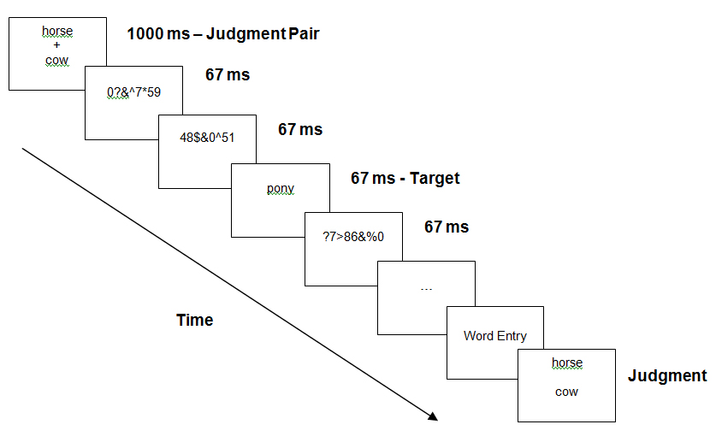

*Figure 1.*

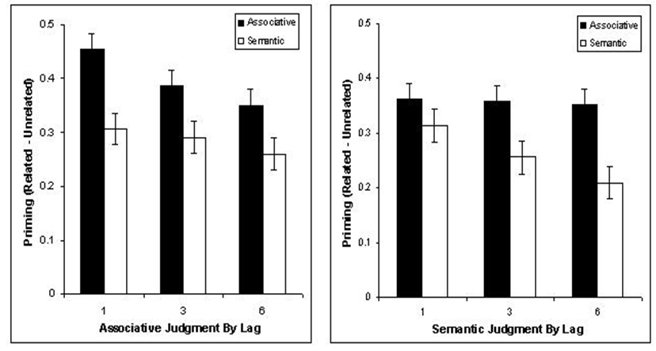

*Figure 2.*

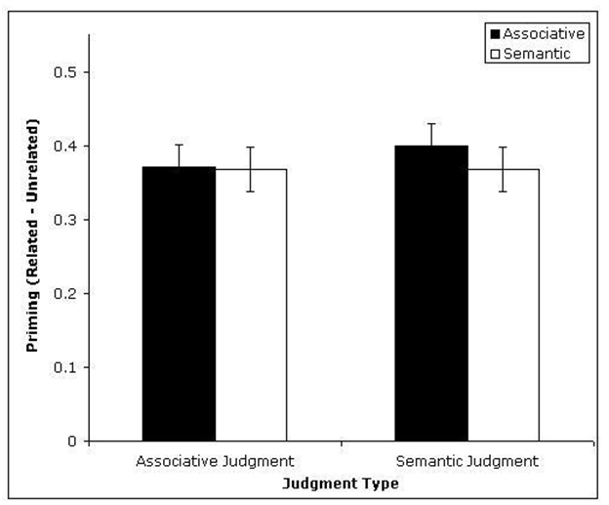

*Figure 3.*

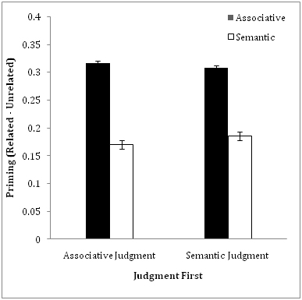

*Figure 4.*